**A**

**Project Report**

**On**

**“MILKNEST ONLINE SERVICES”**

Submitted to

**SHIVAJI UNIVERSITY, KOLHAPUR**

In partial fulfillment of

**BACHELOR OF COMPUTER SCIENCE ENTIRE**

Submitted by

Mr. Santosh Mallikarjun Dundage.

Mr. Harsh Arvind Kshirsagar.

Under the guidance of

**Asst. Prof. P. B. Patil**

**(Msc. Computer)**

Through

The principal

**Prof. (Dr.) S. M. Kadam**

**SHIVRAJ COLLEGE OF ARTS, COMMERCE &**

**D.S. KADAM SCIENCE COLLEGE, GADHINGLAJ**

**DIST. KOLHAPUR**

**2024-2025**

**K.V.R.S.S.S’s**

**SHIVRAJ COLLEGE OF ARTS, COMMERCE &**

**D.S.KADAM SCIENCE COLLEGE, GADHINGLAJ**

**DIST. KOLHAPUR**



CERTIFICATE

This is to certify that ,

1. Mr. Santosh Mallikarjun Dundage.

2. Mr. Harsh Arvind Kshirsagar.

Have successfully completed the project on the topic “MilkNest Online Services” in satisfactory manner for partial fulfillment of Bachelor Of Computer Science(B.C.S) degree for the academic year 2024-25

To the best of our knowledge and belief, the matter presented here is original and has not been submitted elsewhere for the award of any degree.

Date: / /2025

Place: Gadhinglaj

Asst.Prof. Patil P.B. Asst. Prof. Khot R.B.

Project Guide EXAMINER HOD



**K.V.R.S.S.S’s**

**SHIVRAJ COLLEGE OF ARTS, COMMERCE &**

**D.S.KADAM SCIENCE COLLEGE, GADHINGLAJ**

**DIST. KOLHAPUR**

To

The Registrar,

Shivaji University,

Kolhapur.

**Subject:-Recommendation for BCS III Project**.

Respected Sir,

I, Dr. S.M. Kadam the principal of Shivraj College Gadhinglaj,

recommended that the following students,

1. Mr. Santosh Mallikarjun Dundage.

2. Mr. Harsh Arvind Kshirsagar.

Have completed the project report entitled, “MilkNest Online Services”

As per partial fulfillment according to the syllabus of the Shivaji University, Kolhapur under guidance of Asst. Prof. Patil P.B**.**

Date:-

Place:- Gadhinglaj Principal

**Dr.S.M.Kadam**

**K.V.R.S.S.S’s**

**SHIVRAJ COLLEGE OF ARTS, COMMERCE &**

**D.S.KADAM SCIENCE COLLEGE, GADHINGLAJ**

**DIST. KOLHAPUR**

**GUIDANCE CERTIFICATE** 

This is to certify that the project entitled “MilkNest Online Services” conducted at Shivraj College Gadhinglaj by Mr. Santosh Mallikarjun Dundage and Mr. Harsh Arvind Kshirsagar. In partial fulfillment of this work for award of Bachelor of Computer Science (B.C.S) submitted to Shivaji University , Kolhapur has been completed under my supervision and guidance.

To the best of my knowledge and belief, the presented by them is original in nature and has not been from any source. In addition, this report has not been submitted earlier for ant degree or diploma of Shivaji University or any other university.

Place : Gadhinglaj.

date :

Asst. Prof.P.B. Patil.

(Project Guide)

CERTIFICATE

**“MILKNEST ONLINE SERVICES”**

This is to certify that Mr. Santosh Mallikarjun Dundage and Mr. Harsh Arvind Kshirsagar the students of Shivraj College ,Gadhinglaj have developed this project report entitled “MILKNEST ONLINE SERVICES” for our institute.

The data collected and processed is according to our requirement of system .Their work is upto the mark of satisfaction and that was good .As per my knowledge it is their original work and it is carried out very much sincerely.

I wish that all success in their future.

Date:

Place:Gadhinglaj The

Head of institute,

Mr.Sunil Hargapure.

**DECLARATION**

We undersigned hereby declare that this report entitled “MILKNEST ONLINE SERVICES” for Shivraj College of Arts, Commerce and D.S. Kadam Science college , Gadhinglaj, is our original work prepared under guidance of Asst.Prof. P.B. Patil. The Empirical finding in this report are based on data collected by us. The matter presented is this report is not copied from any source.

We understand that such copy is liable for punishment in any way the university Authorities deem to fit. This work has not been submitted to either Shivaji University or any other University.

This work is humbly submitted to Shivaji University ,Kolhapur for the award of the degree of Bachelor of Computer Science (B.C.S)

Date :

Place : Gadhinglaj

Mr. Santosh Mallikarjun Dundage.

Mr. Harsh Arvind Kshirsagar.

ACKNOWLEDGEMENT

It gives great pleasure to remain deeply indebted to our guide Asst.Prof P.B.Patil for providing us with the required facilities for the academic achievement under whom we had the privilege to work. The faith and Confidence shown by him in us boosted our moral and motivated us to perform better in preferring this project.

We are thankful to those who have contributed either directly or indirectly to this project.

Thanking You.

Mr. Santosh Mallikarjun Dundage.

Mr. Harsh Arvind Kshirsagar.

**INDEX**

|  |  |  |
| --- | --- | --- |
| **Sr. No** | **Contents** | **Page No.** |
| **1** | **Introduction To Project**   * Introduction * Existing Manual System * Need of Scope of Computer System * Organization Profile | 1-8 |
| **2** | **Proposed System**   * Objectives of proposed system * Requirement Gathering * SRS | 9-19 |
| **3** | **System Analysis :**   * System Diagram * DFD * ERD | 20-25 |
| **4** | **System Design :**   * Database Design * Input Design * Output Design | 26-47 |
| **5** | **Implementation**   * Hardware * Software | 48-50 |
| **6** | **Reports** | 51-56 |
| **7** | **Suggestions and Conclusion** | 57-59 |
| **8** | **Bibliography** | 60-61 |

**CHAPTER 1:**

**INTRODUCTION**

**TO PROJECT**

* **Introduction**
* **Existing System**
* **Need and scope of Computer**

**system**

* **Organization Profile**

**Introduction**

**ABOUT PROJECT**

The project entitled “MILKNEST ONLINE SERVICES ”for a software program. This project is developed for “SHREE SAI MILK SHOP” the information for this project is collected from” **SHREE SAI MILK SHOP DUNDAGE”**.

The information stored Database is used for report generation. The System is specially designed to maintain storage item, product detail, customer detail and bill.

This system can be used in mobile shop. This system can be used to manage all records and database. The project will help the store keeper fast billing .Easy to maintain in future prospect. The project cannot be used for other in other managements.

**Existing System**

**EXISTING SYSTEM**

* Previous data cannot be finding quickly.
* Less accuracy.
* Difficulty in management system.
* Lack of security.
* Difficulty to managing multiple forms.
* As mentioned above most of details are maintained manually. Due to this data retrieved is time consuming.
* Due to human calculation error occurs.
* Data are stride an excel sheet which take lot of time.
* Data may be corrupted.

**LIMITATION OF EXISTING SYSTEM**

* Existing system is completely depending on manual work that is information stored in register and other book.
* In existing system more man power is required. The information stored is not accurate because various mistakes are there in data filling process.
* To store large amount of data, more stationary is required which increases the cost of stationary and hence lot of money and manpower were required.
* In existing system lot of time is spent on managing different registers.
* In an existing system, we cannot modify the records and also we cannot backup the document.
* In an existing system all the works are done manually and hence if the person is not present then the other work was got stopped due to which the system get stopped .

**Need & Scope of Computer System**

**Need of a Computer System**

A computer system is essential for managing and operating a website for milk and milk products. It ensures efficiency, automation, and accuracy in various business processes. The key needs include:

* **E-Commerce Functionality**

Enables online sales, order processing, and payment integration.

* **Inventory Management**

Helps track stock levels, expiry dates, and product availability.

* **Customer Management**

Maintains customer records, orders, and preferences.

* **Billing & Invoicing**

Generates invoices, manages payments, and automates accounting.

* **Supply Chain Management**

Monitors suppliers, deliveries, and logistics.

* **Quality Control**

Tracks product quality, safety standards, and compliance.

* **Marketing & Promotions**

Supports digital marketing, promotions, and customer engagement.

* **Customer Support**

Provides chat support, FAQs, and grievance handling.

**Scope of a Computer System**

The scope of a computer system for a milk and dairy products website extends across multiple functions:

1. **Website Development & Hosting**
   * User-friendly interface for easy navigation.
   * Mobile-responsive design for better accessibility.
   * Secure hosting and data protection.
2. **E-Commerce & Online Ordering**
   * Product catalog with descriptions and prices.
   * Shopping cart and secure payment gateways.
   * Order tracking and delivery scheduling.
3. **Inventory & Supply Chain Management**
   * Real-time stock updates and warehouse tracking.
   * Integration with suppliers and distributors.
   * Automated restocking alerts.
4. **Customer Relationship Management (CRM)**
   * Personalized recommendations based on purchase history.
   * Subscription-based delivery services.
   * Customer feedback and review management.
5. **Marketing & SEO**
   * Social media integration for promotions.
   * Search engine optimization (SEO) for better online visibility.
   * Email and SMS marketing for offers and updates.
6. **Data Analytics & Reporting**
   * Sales and revenue tracking.
   * Customer behaviour analysis.
   * Performance reports for decision-making.
7. **Security & Compliance**
   * Secure transactions with SSL encryption.
   * Data protection and privacy policies.
   * Compliance with food safety regulations.

**Organization Profile**

**ORGANIZATION PROFILE**

* **Organization Name:-**

SHREE SAI MILK SHOP

* **Venue: -**

DUNDAGE

* **Mobile No:-**

+91 9527086279

* **Year of establishment:-**

2016

* **Owner:-**

Mr. Sunil Hargapure

* **Area of Work:-**

SANKSESHWAR ROAD ,NEAR INDIAN OIL PETROL PUMP MAIN ROAD DUNDAGE,

TAL – GADHINGLAJ, DIST-KOLHAPUR

**CHAPTER 2:**

**PROPOSED SYSTEM**

* **Objectives**
* **Requirement Gathering**
* **SRS**

**Objectives**

The objective of a Milk Nest Online Service Software Management System project is to create a comprehensive, user-friendly, and efficient platform to manage the operations of a milk distribution or delivery service. The key goals typically include:

**1. Order Management:**

Automate the process of ordering milk products online, allowing to place and track their orders easily.

**2. Inventory Management:**

Manage the stock of milk and related products, ensuring timely updates of inventory levels, automatic reordering, and alerts for low stock.

1. **Customer Management:**

Maintain a detailed customer database, track preferences, manage accounts, and provide discounts.

1. **Payment Integration:**

Implement secure and flexible payment gateways for seamless transactions, including subscriptions, one-time orders, and bill management.

**6.** **Delivery Management:**

Facilitate the organization of delivery routes, assign delivery personnel, and track deliveries in real time for both customers and service managers.

**7. Analytics and Reporting:**

Provide insights into sales trends, customer behavior, inventory levels, and delivery performance through comprehensive reports and analytics.

**8. User-Friendly Interface:**

Ensure that both customers and staff (admin, delivery personnel) can easily navigate the system, with intuitive dashboards and self-service options.

**9. Scalability:**

Build a system capable of scaling with business growth, supporting multiple locations, increasing customer volume, and expanding service offerings. By achieving these objectives, the system will improve operational efficiency, customer satisfaction, and overall business profitability for the milk nest online service.

**Requirement Gathering**

**Proposed System**

The proposed system is computerized and has been developed using advance language therefore it gives more facilities than present system. It provides quick access to any data. In this system user have to enter the data only once and then it get linked with all files. This reduces the workload of user and it is also a time saving process. The information about any Subscriber can be easily retrieved. The system maintains all records easy.

* + The new system will convert manual work to the computerized work.
  + By converting manual work to the computerized work in that case it will remove all paper work.
  + By maintaining all the work on computer will increase our accuracy as well as speed of our work.
  + It will easily used and the time consuming is decreased.

**Advantages of Proposed System**

* Computerized Mobile Shop System is better than the Manual Shop System.
* Accuracy and Security can be maintained easily by the Admin.

* It can handle all the Information about the Customer, Clients, Items and Admin.

* All the information about sale, purchase will be maintain properly in this system.
* All manual calculation of sale or all the money management will be performed by the computer automatically.
* This system will provide timely report information.
* It will produce report for sale, bill information.
* The computer can hold amount of data in its storage device.
* The operation and speed of the computer is very high.
* We can calculate result and print any report within seconds.

**System Requirement Specification (SRS)**

**Software Requirement :**

* **JAVA.**
* **My-SQL workbench.**
* **Apache Netbeans IDE 22.**
* **Jasper Report 5.1**
* **Operating System:-Windows-7 64 bit.**

**Frontend :**

* **JSP, SERVERLET**
* **JSP (HTML, CSS)**

**Backend :**

* **My-SQL SERVER**

**Hardware Requirement :**

* **Intel Dual Core or Higher Processor.**
* **2 GB of RAM or Above.**
* **Minimum 20 GB Hard-Disk.**
* **Computer and Other Devices.**

**ABOUT JAVA**

Java is an object-oriented programming language developed by James Gosling and Colleagues at Sun Microsystem in early 1990s. Unlike conventional languages which are generally designed either to be compiled to native code, or to be interrupted from source code at runtime, Java is intended to be compiled to a byte code, which is then run (generally using JIT compilation) by a Java Virtual Machine.

Java was started as a project called “oak” by James Gosling in June 1991. Gosling goals were to implemented a virtual machine and a language that had a familiar C-like notation but with greater uniformly and simplicity then C and C++. The first public implementation was Java 1.0 in 1995. It made the promise of “Write Once, Run Anywhere”, with free runtimes on popular platforms. It was fairly secure and its security was configurable, allowing for network and access to be limited. The major web browsers soon incorporated it into their standard configuration in secure “Applet” configuration popular quickly. New versions for large and small platforms (J2EE and J2ME) soon were designed with the advent of “Java 2”. Sun has not announced any plans for a “Java 3”.

**ABOUT JAVA NET BEANS IDE 24**

The NetBeans Platform is a framework for simplifying the development of Java Swing desktop applications. The NetBeans IDE bundle for Java SE contains what is needed to start developing NetBeans plugins and NetBeans Platform based applications no additional JDK is required.

Applications can install modules dynamically. Any application can include the Update Centre module to allow users of the application to download digitally signed upgrades and new features directly into the running application. Reinstalling an upgrade or a new release does not force users to download the entire application again.

The platform offers reusable services common to desktop applications, allowing developers to focus on the logic specific to their application. Among the features of the platform are:

NetBeans IDE is an open-source integrated development environment. NetBeans IDE supports development of all Java application types (Java SE (including JavaFX), Java ME, web, EJB and mobile applications) out of the box. Among other features are an Ant-based project system, Maven support, refactoring, version control (supporting CVS, Subversion, Mercurial and Clear case).

**Modularity**:

All the functions of the IDE are provided by modules. Each module provides a well-defined function, such as support for the Java language, editing, or support for the CVS versioning system, and SVN. NetBeans contains all the modules needed for Java development in a single download, allowing the user to start working immediately. Modules also allow NetBeans to be extended. New features, such as support for other programming languages, can be added by installing additional modules. For instance, Sun Studio, Sun Java Studio Enterprise, and Sun Java Studio Creator from Sun Microsystems are all based on the NetBeans IDE.

**License:**

From July 2006 through 2007, NetBeans IDE was licensed under Sun's Common Development and Distribution License (CDDL), a license based on the Mozilla Public License (MPL). In October 2007, Sun announced that NetBeans would henceforth be offered under a dual license of the CDDL and the GPL version 2 licenses, with the GPL linking exception for GNU Class path

* User Interface Management (e.g. Menus and Toolbars)
* User Settings Management
* Storage Management (Saving and Loading any Kind of Data)
* Window Management
* Wizard Framework (Supports Step-by-Step Dialogs)
* NetBeans Visual Library
* Integrated Development Tools

**WHAT IS DATABSASE**

A database is a separate application that stores a collection of data. Each database has one or more distinct Application for creating, accessing managing, searching and replicating the data it holds. Other kinds of data stores can be used such as files on the file system or large hash tables in memory but data fetching and writing would not be fast and easy with those types of systems.

So now a day we use relational database management systems (RDBMS) TO store and manage huge volume of data. This is called relational database because all the data is stored into different bales and relations are established using primary keys or other keys known as foreign keys.

**RELATIONAL DATABASE MANAGEMENT SYSTEM**

* Enables you to implement a database with tables, columns and indexes.
* Guarantees the Referential Integrity between rows of various tables.
* Updates the indexes automatically.
* Interprets a SQL query and combines information from various tables.

**My SQL DATABASE**

# SQL Server Management Studio

SQL is a fast, easy-to-use RDBMS being used for many small and big businesses. SQL was initially developed at IBM by DONALD Chamberlin and Raymond Boyce after learning about the relation model from Ted Cod in the early 1970 s.:

* SQL is released under an open-source license. So you have nothing to pay to use it.
* SQL is a very powerful program in its own right. It handles a large subset of the functionality of the most expensive and powerful database packages.
* SQL uses a standard form of the well-known SQL data language.
* SQL works on many operating systems and with many languages including PHP, PERL, C, C++, JAVA, etc.
* SQL works very quickly and works well even with large data sets.
* SQL is very friendly to all language, the most appreciated language for web development.
* SQL supports large databases, up to 50 million rows or more in a table. The default file size limit for a table is 4GB, but you can increase this (if your operating system can handle it) to a theoretical limit of 8 million terabytes (TB).

**CHAPTER 3:**

**SYSTEM**

**ANALYSIS**

* System Diagram
* DFD
* ERD

**System Diagram**

**SYSTEM DEVELOPMENT LIFE CYCLE**

**THE PROCESS MODEL USED FOR THE SYSTEM:**

The process model used for this system “Classic Life Cycle” as this is simple and is best for small scale project.

The “Classic Life Cycle” is also called System Development Life Cycle (SDLC). It is defined “The growth of an information system is through various identifiable stages. These stages are grouped together and referred as SDLC.” The structure of its stages which we used in our project is as follows:

**WATERFALL MODEL:**

**System**

**Analysis**

**Design**

**Code**

**Testing**

**Maintenance**

**System**

**Analysis**

**Design**

**Code**

**Testing**

**Maintenance**

**Data Flow Diagram (DFD)**

**DFD 0th Level Diagram :-**

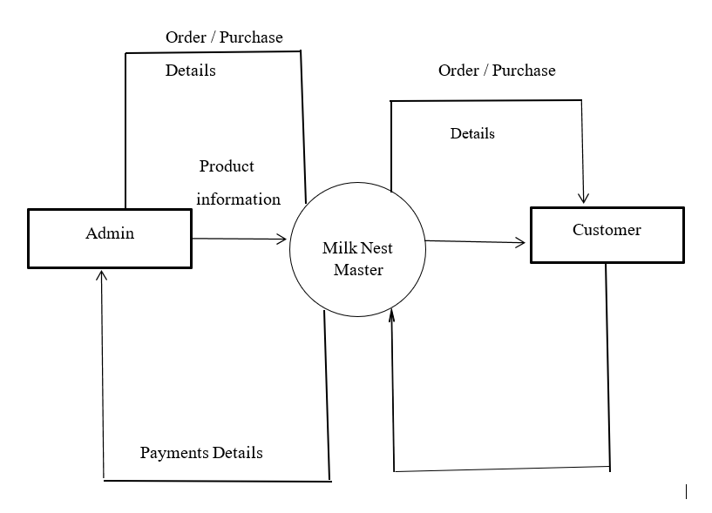

**1st Level DFD:**

1. **Customer to Admin (Website purchase):-**

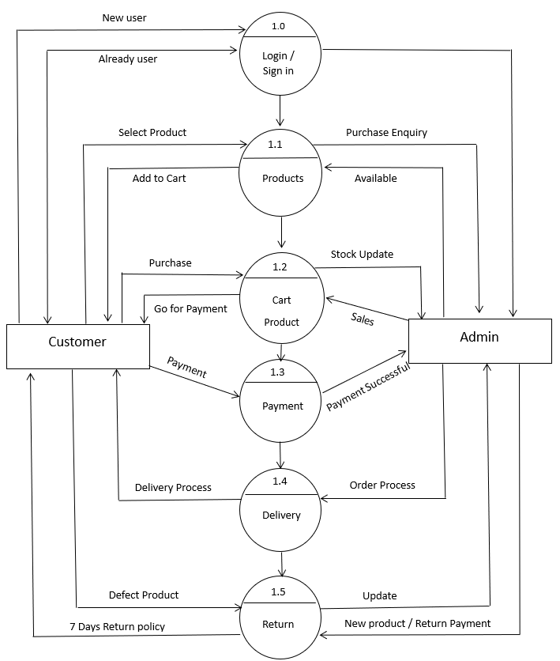

1. **Admin to Stock (on shop purchase):-**

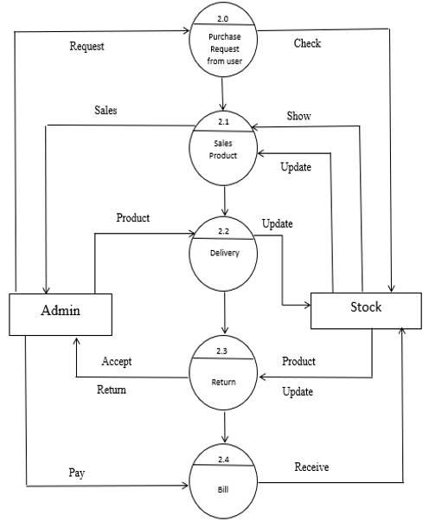

**Entity Relationship Diagram (ERD)**

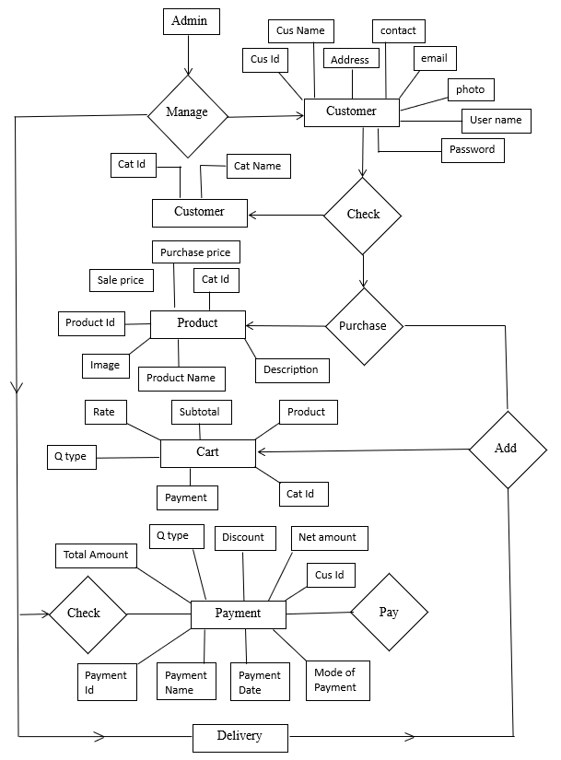

**CHAPTER 4:-**

C:\Program Files (x86)\Microsoft Office\MEDIA\CAGCAT10\j0291984.wmf

**SYSTEM DESIGN**

* **Database Design**
* **Source Code**
* **Form Design**

|  |  |  |  |
| --- | --- | --- | --- |
| Column name | Data Type | Constraint | Description |
| Cart_ID | INT | Primary Key | Carts Items ID |
| Product_Name | Varchar (45) | - | Product Name |
| User_ID | INT | - | User ID |
| Quantity | INT | - | Quantity of Product |
| Price | Decimal (10,2) | - | Rate of product |

**DatabaseDesign**

1. **Table Cart Master :**

**2)Table Category master :**

|  |  |  |  |
| --- | --- | --- | --- |
| Column name | Data Type | Constraint | Description |
| Category_ID | INT | Primary Key | Carts Items ID |
| Category_Name | VarChar(45) | - | Name of category |

**3)Table customer Master :**

|  |  |  |  |
| --- | --- | --- | --- |
| Column name | Data Type | Constraint | Description |
| Customer_ID | INT | Primary Key | Customer ID |
| |  |  | | --- | --- | | Customer_Name |  | | Varchar (45) | - | Name of customer |
| |  |  | | --- | --- | | Customer_Adress |  | | Varchar (150) | - | Adress of customer |
| Customer_Contact | Varchar (45) | - | Contact number |
| Customer_Email | Varchar (45) | - | Email id of customer |
| |  |  | | --- | --- | | Customer_Photo |  | | Varchar (45) | - | Photo of customer |
| Customer_Username | Varchar (45) | - | username |
| Customer_Password | Varchar (45) | - | password |

**4)Table Payment Master :**

|  |  |  |  |
| --- | --- | --- | --- |
| Column name | Data Type | Constraint | Description |
| Payment_ID | INT | Primary Key | Payment ID |
| Payment_name | Varchar (45) | - | Name of payer |
| Payment_date | Date | - | Payment date |
| Payment_mode | Varchar (45) | - | Payment mode |
| Total_Amount | Decimal (10,0) | - | Total Amount |
| Quantity | INT | - | Quantity |
| Discount | Decimal (10,0) | - | Discount |
| Net_amount | Decimal (10,0) | - | Net amount |
| Customer_ID | INT | - | Customer ID |

**5)Table product Master :**

|  |  |  |  |
| --- | --- | --- | --- |
| Column name | Data Type | Constraint | Description |
| Product ID | INT | Primary Key | Product ID |
| Product_name | Varchar (45) | - | Product name |
| Product_Image | Varchar (45) | - | Product Image |
| Product_Description | Varchar (45) | - | Product Description |
| Product_Sale_price | Decimal (10,0) | - | Product Sale price |
| Product_Purchase_price | Decimal (10,0) | - | Purchase price of product |
| Product_Cat_ID | INT | - | Product Category ID |

**6)Table User Master :**

|  |  |  |  |
| --- | --- | --- | --- |
| Column name | Data Type | Constraint | Description |
| User_ID | INT | Primary Key | User ID |
| User_name | Varchar (16) | - | User name |
| User_contact | Varchar (45) | - | User contact Number |
| User_email | Varchar (50) | - | User email ID |
| User_Password | Varchar (45) | - | User Password |

**6)Table Admin Master :**

|  |  |  |  |
| --- | --- | --- | --- |
| Column name | Data Type | Constraint | Description |
| Admin_ID | INT | Primary Key | Admin ID |
| Admin_Name | Varchar (45) | - | Admin Name |
| Admin_Contact | Varchar (45) | - | Admin Contact |
| Admin_Email | Varchar (45) | - | Admin Email |
| Admin_Username | Varchar (45) | - | Admin Username |
| Admin_Password | Varchar (45) | - | Admin Password |

**7)Table Orders Master :**

|  |  |  |  |
| --- | --- | --- | --- |
| Column name | Data Type | Constraint | Description |
| Order_Id | INT | Primary Key | Order Id |
| User_Id | INT | - | User Id |
| Product_Id | INT | - | Product Id |
| Quantity | INT | - | Quantity |
| Total_Amount | INT | - | Total Amount |
| Payment_Method | Varchar(50) | - | Mode of payment |
| Payment_Details | Varchar(50) | - | Payment Details |
| Order_Date | Time | - | Date of Order |

**Source Code**

<%--

Document : header1

Created on : 29 Dec 2024, 10:30:45 am

Author : Santosh

--%>

<%@page import="java.sql.ResultSet"%>

<%@page import="com.milknest.milknest_online_services.category"%>

<%@page contentType="text/html" pageEncoding="UTF-8"%>

<%@page import="com.milknest.milknest_online_services.insertCart"%>

<%@page import="java.sql.DriverManager"%>

<%@page import="java.sql.PreparedStatement"%>

<%@page import="java.sql.Connection"%>

<%@page import="com.mysql.cj.Session"%>

<link href="https://cdn.jsdelivr.net/npm/bootstrap@5.3.0/dist/css/bootstrap.min.css" rel="stylesheet">

<!-- Include Bootstrap JS (With Popper) -->

<script src="https://cdn.jsdelivr.net/npm/bootstrap@5.3.0/dist/js/bootstrap.bundle.min.js"></script>

<%

if (request.getParameter("btnLogout") != null) {

session.removeAttribute("username");

response.sendRedirect("Login.jsp");

}

Integer userIddd = (Integer) session.getAttribute("userId");

int totalCartProducts = 0;

if (userIddd != null) {

try {

insertCart cartHelper = new insertCart();

totalCartProducts = cartHelper.getTotalCartProducts(userIddd);

} catch (Exception e) {

e.printStackTrace();

}

}

%>

<!-- Google Web Fonts -->

<link rel="preconnect" href="https://fonts.gppgleapis.com">

<link rel="preconnect" href="https://fonts.gstatic.com">

<link href="https://fonts.googleapis.com/css2?family=Poppins:wght@100;200;300;400;500;600;700;800;900&display=swap" rel="stylesheet">

<!-- Font Awesome -->

<link href="https://cdnjs.cloudflare.com/ajax/libs/font-awesome/5.10.0/css/all.min.css" rel="stylesheet">

<!-- Libraries Stylesheet -->

<link href="lib/owlcarousel/assets/owl.carousel.min.css" rel="stylesheet">

<!-- Customized Bootstrap Stylesheet -->

<link href="css/style.css" rel="stylesheet">

<meta charset="UTF-8">

<meta name="viewport" content="width=device-width, initial-scale=1.0">

<link href="bootstrap/css/bootstrap.css" rel="stylesheet" type="text/css"/>

<link href="bootstrap/css/bootstrap.min.css" rel="stylesheet" type="text/css"/>

<%!

ResultSet rs;

String category_img;

category cat = new category();

%>

<!DOCTYPE html>

<html lang="en">

<head>

<meta charset="UTF-8">

<meta name="viewport" content="width=device-width, initial-scale=1.0">

<title>MilkNest Online Services</title>

<!-- Style Link -->

<link rel="stylesheet" href="style.css">

<!-- box icons -->

<link rel="stylesheet"

href="https://cdn.jsdelivr.net/npm/boxicons@latest/css/boxicons.min.css">

</head>

<body>

<!-- Topbar Start -->

<div class="container-fluid bg-light">

<div class="row py-2 px-xl-5">

<div class="col-lg-6 d-none d-lg-block">

<div class="d-inline-flex align-items-center">

<a class="text-dark" href="#">FAQs</a>

<span class="text-muted px-2">|</span>

<a class="text-dark" href="#">Help</a>

<span class="text-muted px-2">|</span>

<a class="text-dark" href="#">Support</a>

</div>

</div>

<div class="col-lg-6 text-center text-lg-right">

<div class="d-inline-flex align-items-center">

<a class="text-dark px-2" href="#"><i class="fab fa-facebook-f"></i></a>

<a class="text-dark px-2" href="#"><i class="fab fa-twitter"></i></a>

<a class="text-dark px-2" href="#"><i class="fab fa-linkedin-in"></i></a>

<a class="text-dark px-2" href="#"><i class="fab fa-instagram"></i></a>

<a class="text-dark pl-2" href="#"><i class="fab fa-youtube"></i></a>

</div>

</div>

</div>

</div>

</a>

<header>

<h1 class="logo"><a href="Admin/admin_login.jsp">MilkNest</a></h1>

<!-- <div class ="bx bx-menu" id="menu icon"></div> -->

<ul class="navbar">

<li><a href="Home.jsp">Home</a></li>

<li><a href="Shop.jsp">Shop</a></li>

<li><a href="aboutus.jsp">About us!</a></li>

<li><a href="contact.jsp">Contact</a></li>

<!-- <li><a href="Review.jsp">Review</a></li>-->

<%

if (session.getAttribute("username") == null) {

%>

<li class="nav-item">

<a class="nav-link" href="Login.jsp">LogIn/Register</a>

</li>

<%

}

%>

</ul>

<%

if (session.getAttribute("username") != null) {

%>

<!-- Cart Icon -->

<div class="col-lg-3 col-6 text-right">

<a href="frmCart.jsp" class="text-reset">

<i class="fas fa-shopping-cart"></i>

<span class="badge badge-success"><%= totalCartProducts%></span>

</a>

</div>

<%

}

%>

<!-- User Dropdown -->

<!-- Include Bootstrap CSS -->

<%

String str = (String) session.getAttribute("username");

if (str != null) {

%>

<!-- Show dropdown when user is logged in -->

<div class="nav-item dropdown">

<a class="nav-link dropdown-toggle" href="#" id="navbarDropdown" role="button" data-bs-toggle="dropdown" aria-expanded="false">

<i class="fa fa-user mr-2"></i> <%= str%>

</a>

<ul class="dropdown-menu dropdown-menu-end" aria-labelledby="navbarDropdown">

<li><a class="dropdown-item" href="MyAccount.jsp">My Account</a></li>

<li><a class="dropdown-item" href="Settings.jsp">Settings</a></li>

<li><hr class="dropdown-divider"></li>

<li>

<form method="POST" action="Home.jsp">

<button type="submit" name ="btnLogout"class="dropdown-item">Logout</button>

</form>

</li>

</ul>

</div>

<%

} else {

%>

<!-- Show only "Guest" when user is NOT logged in -->

<div class="nav-item">

<span class="nav-link"><i class="fa fa-user mr-2"></i> Guest</span>

</div>

<%

}

%>

</header>

<!--Home-->

<section class="home" id="about">

<div class="home-text" >

<span>Welcome To</span>

<h1>MilkNest</h1>

<h2>Delivering Freshness, Every Day!</h2>

<form id="search-box" method="GET" action="SerachBar.jsp">

<input class="form-control" id="search-input" type="text" name="query" placeholder="Search for Products..." aria-label="Search" style="width:330px;">

<button class="btn btn-success mt-2" type="submit">Search</button>

</form>

<!-- <form class="form-inline justify-content-md-start" id="search-box" method="GET" action="Search.jsp">

<div class="input-group-prepend">

<span class="input-group-text"><i class="fas fa-search"></i></span>

<input class="form-control mr-sm-2" id="search-input" type="search" name="query" placeholder="Search for Products here..." aria-label="Search">

<button class="btn btn-success my-2 my-sm-0" type="submit">Search</button>

</div>

</form>-->

<div class="home-img">

<img src="https://im.whatshot.in/img/2020/Apr/default-milk-dairy-12-1586346280.jpg" alt="">

</div>

</section>

<!-- Features Start -->

<div class="container-fluid pt-0 m-8">

<div class="row px-xl-5 pb-3 m-5">

<div class="col-lg-3 col-md-6 col-sm-12 pb-1">

<div class="d-flex align-items-center border w-100 mb-4" style="padding: 30px;">

<h1 class="fa fa-check text-primary m-0 mr-3"></h1>

<h5 class="font-weight-semi-bold m-0">Quality Product</h5>

</div>

</div>

<div class="col-lg-3 col-md-6 col-sm-12 pb-1">

<div class="d-flex align-items-center border mb-4" style="padding: 30px;">

<h1 class="fa fa-shipping-fast text-primary m-0 mr-2"></h1>

<h5 class="font-weight-semi-bold m-0">Free Shipping</h5>

</div>

</div>

<div class="col-lg-3 col-md-6 col-sm-12 pb-1">

<div class="d-flex align-items-center border mb-4" style="padding: 30px;">

<h1 class="fas fa-exchange-alt text-primary m-0 mr-3"></h1>

<h5 class="font-weight-semi-bold m-0">1-Day Return</h5>

</div>

</div>

<div class="col-lg-3 col-md-6 col-sm-12 pb-1">

<div class="d-flex align-items-center border mb-4" style="padding: 30px;">

<h1 class="fa fa-phone-volume text-primary m-0 mr-3"></h1>

<h5 class="font-weight-semi-bold m-0">24/7 Support</h5>

</div>

</div>

</div>

</div>

<!-- Featured End -->

<!-- ***************** Categoreis **************-->

<section class="shop" id="shop">

<div class="heading">

<h3>Shop now</h3>

<h1>Milk and Milkproducts</h1>

</div>

<div class="shop-container">

<div class="box">

<div class="box-img">

<!-- <img src="" alt="">-->

</div>

</div>

</div>

<section class="container mb-5">

<div class="categories d-flex flex-wrap justify-content-center">

<%

rs = cat.getAllCategories();

do {

String category_name = rs.getString("category_name");

category_img = rs.getString("category_img");

%>

<a href="ShopByCategories.jsp?catid=<%=rs.getInt(1)%>" class="shop-by-category-link">

<div class="shop-by-category-item">

<div class="shop-by-category-section-container">

<img src="<%=category_img%>" alt="Category">

</div>

<div class="shop-by-category-section-container">

<span class="shop-by-category-header"><%=category_name%></span>

</div>

</div>

</a>

<% } while (rs.next());%>

</div>

</section>

</section>

<!-- ***************** Categoreis **************-->

<!-- link to custom js -->

<script src="main.js"></script>

</html>

</body>

**Form Design**

* 1. Login.jsp

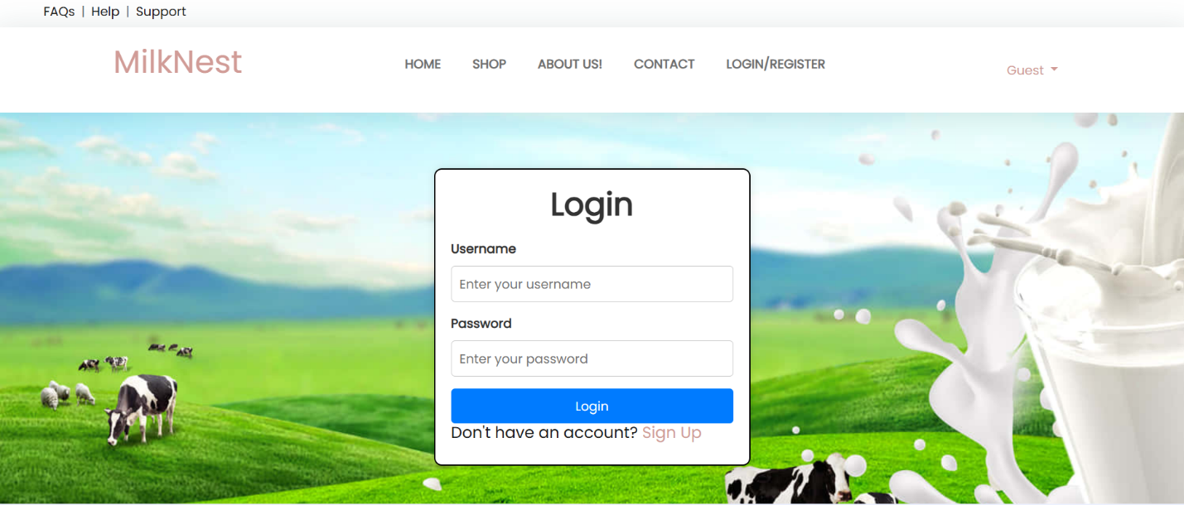

* 1. SignUp.jsp

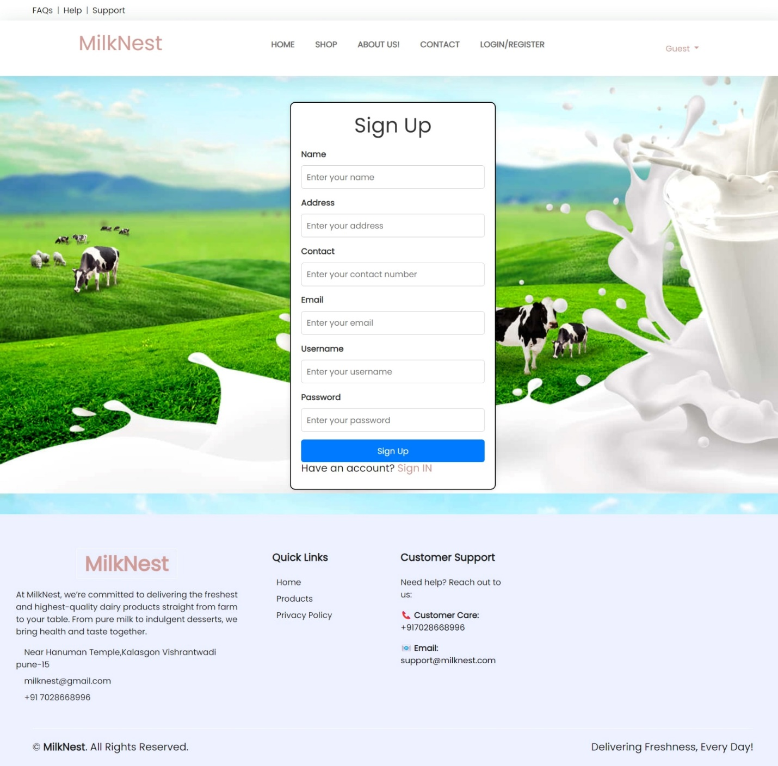

* 1. AboutUs.jsp

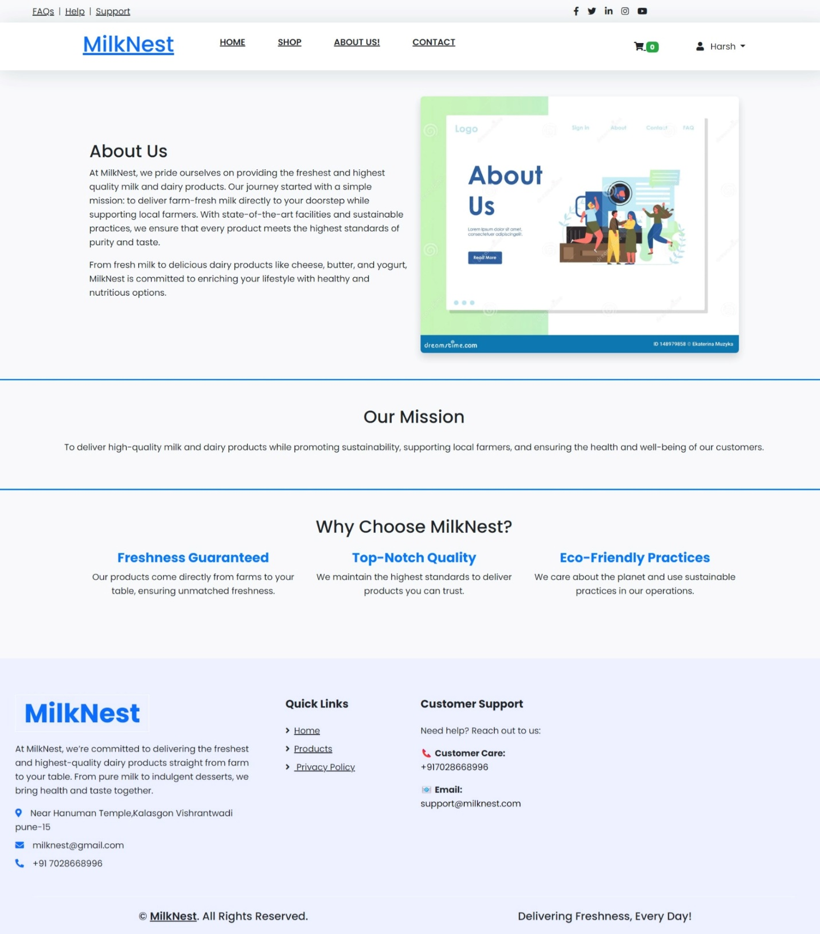

* 1. Contact.jsp

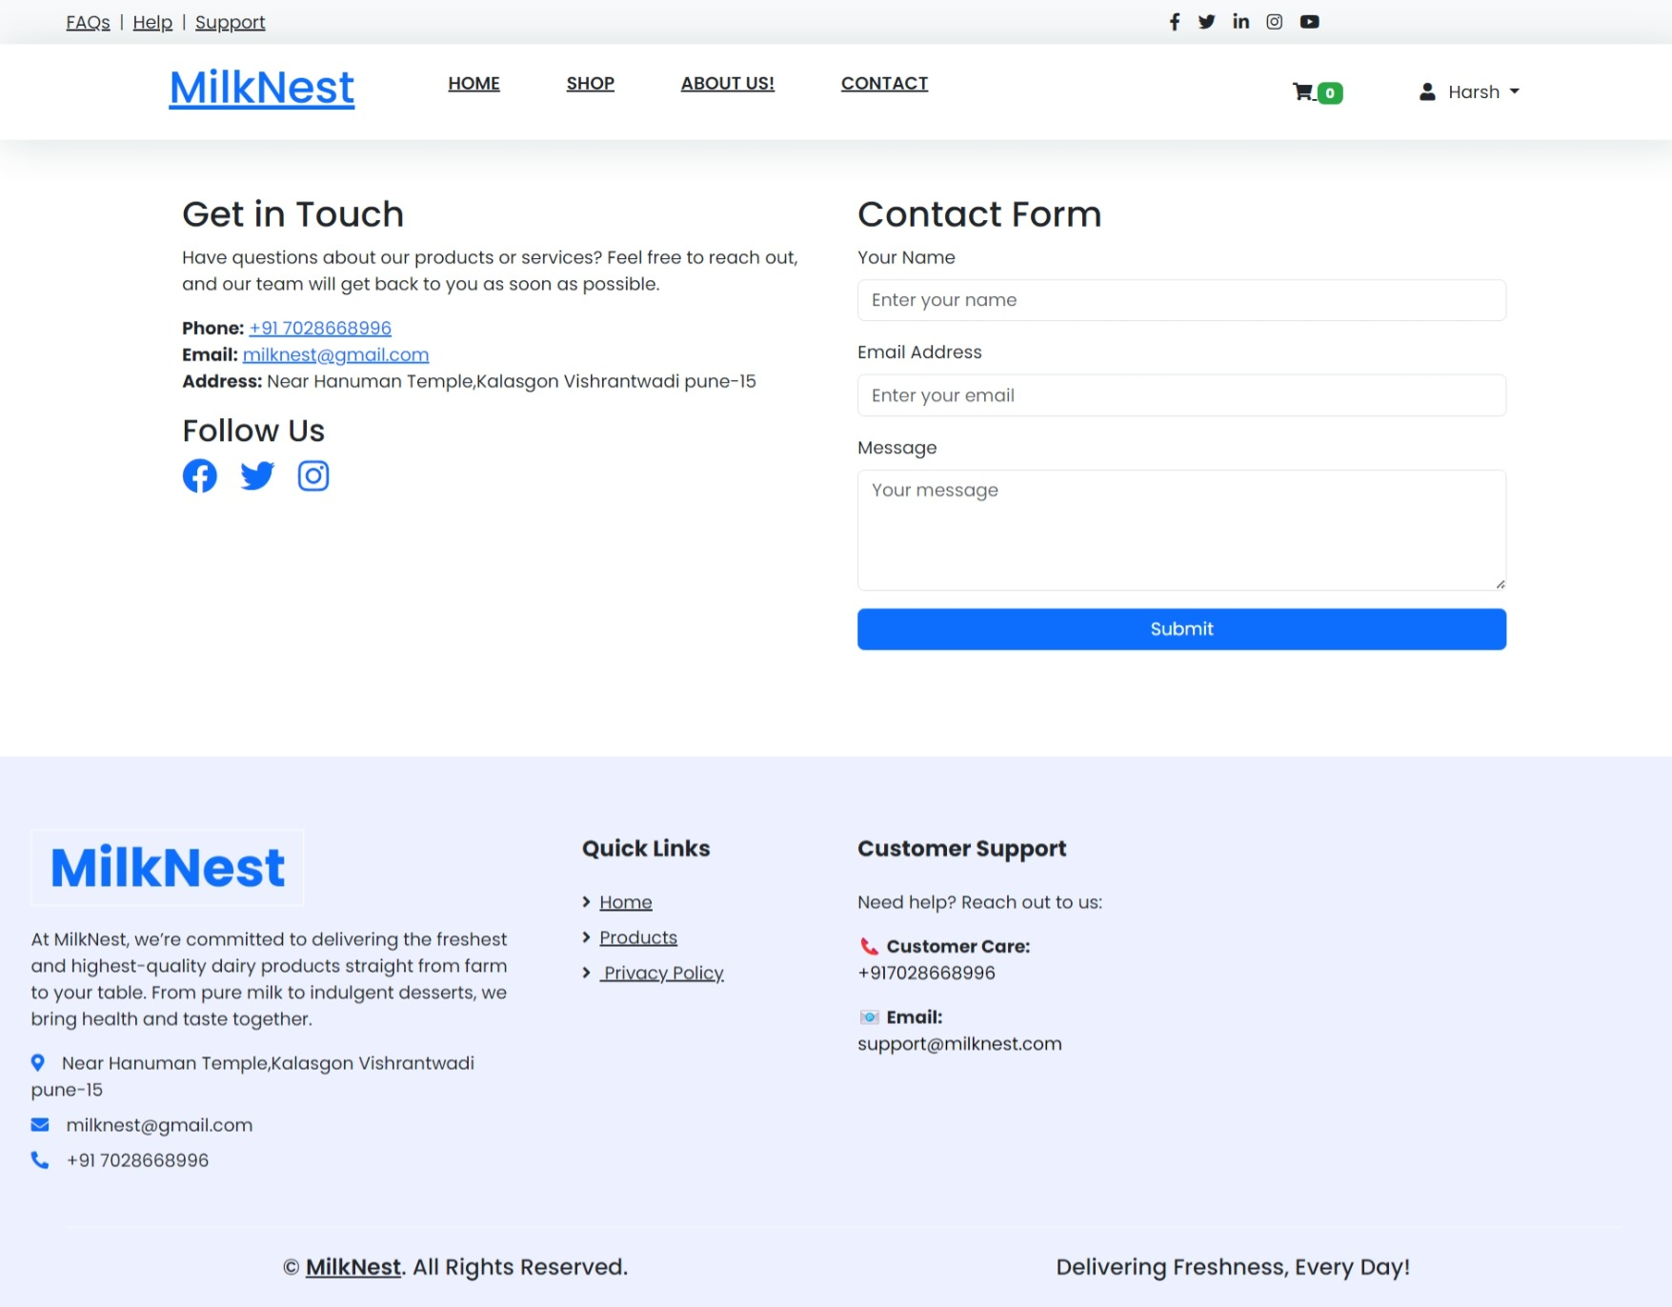

* 1. Home.jsp

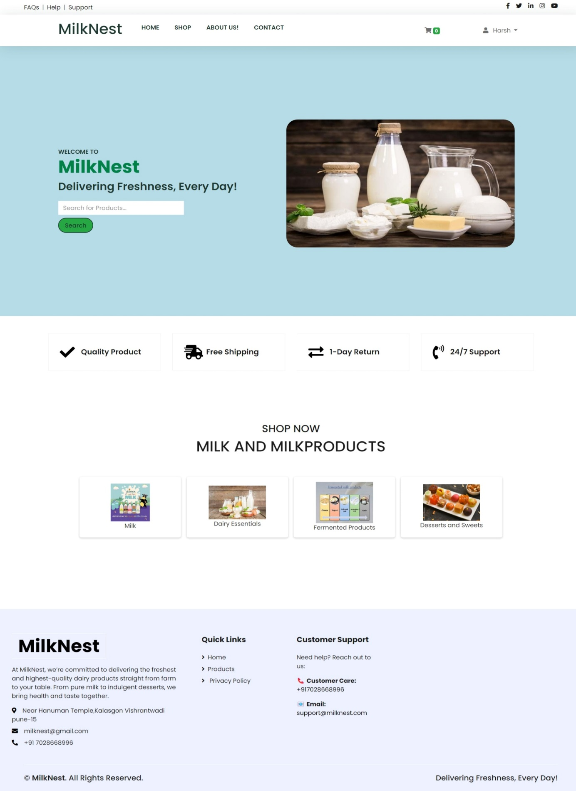

* 1. Shop .jsp

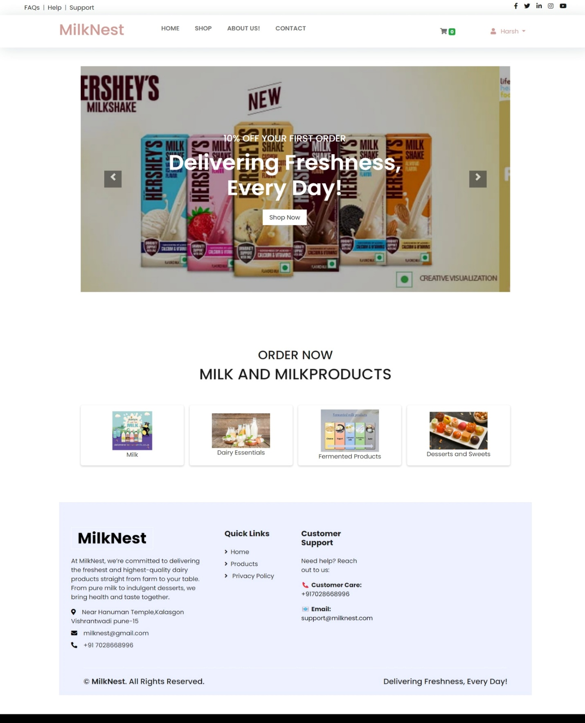

* 1. Shop By Categoeries.jsp

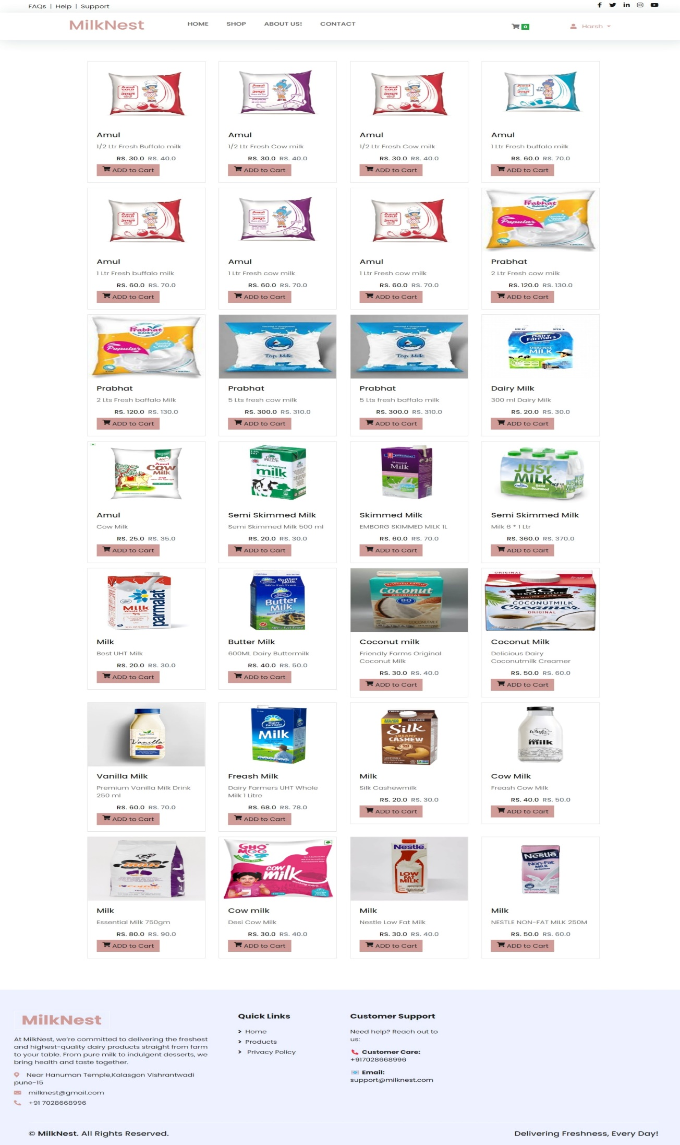

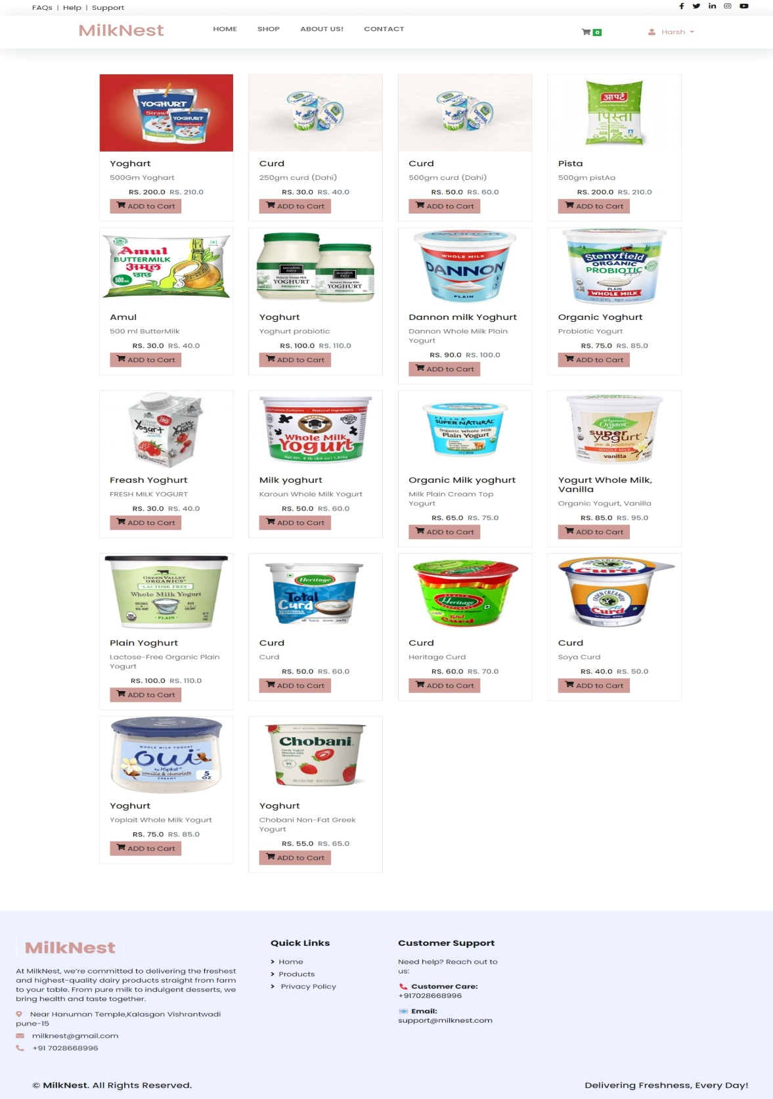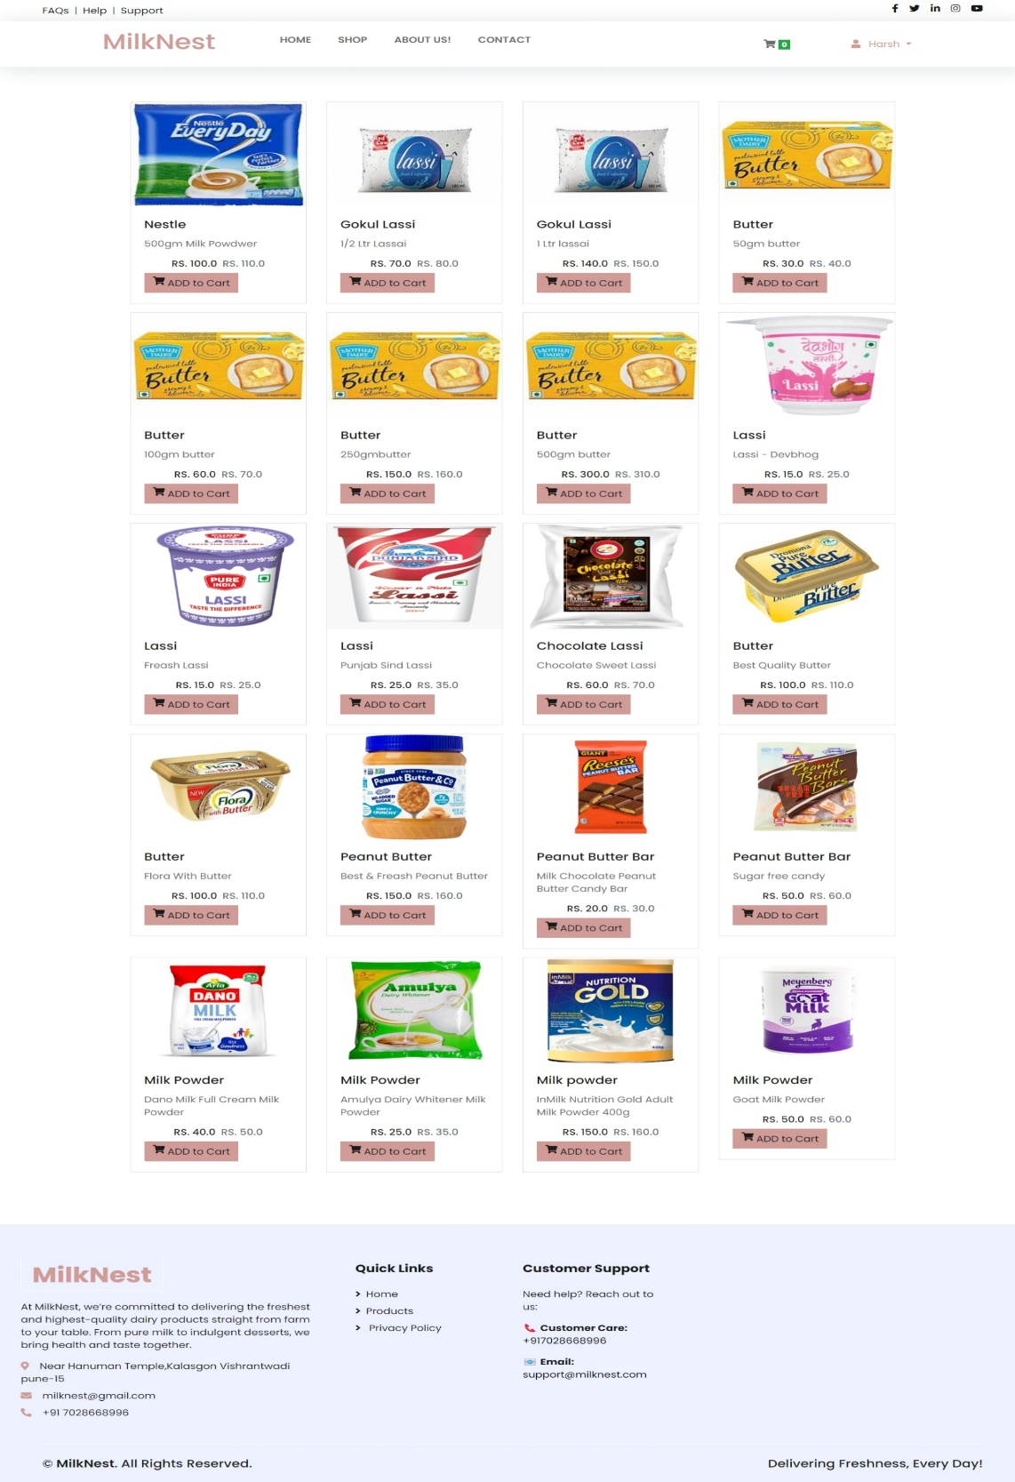

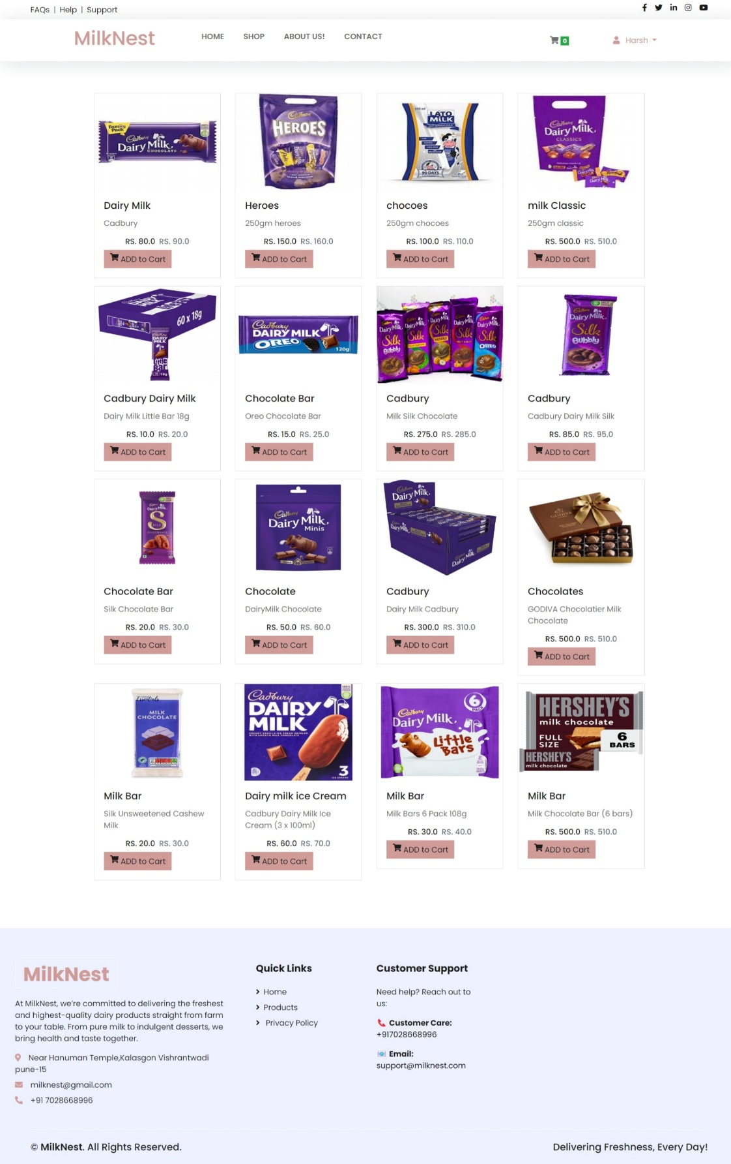

**CHAPTER 5:**

**C:\Program Files (x86)\Microsoft Office\MEDIA\CAGCAT10\j0285750.wmf**

**IMPLEMENTATION**

* **Hardware**
* **Software**

**Hardware Implementation**

The hardware setup depends on the scale of the website. Here are the essential components:

**1) Server Infrastructure**

* **Web Hosting Server** (Cloud-based or Dedicated)
  + **Cloud Options**: AWS, Google Cloud, Microsoft Azure, DigitalOcean
  + **Dedicated Server**: For large-scale operations, consider using a dedicated hosting provider like OVH or self-hosting
* **Storage & Backup**: SSD or NVMe for faster access, RAID-configured storage for redundancy
* **Content Delivery Network (CDN)**: Cloudflare or AWS CloudFront to enhance website speed

**2) Networking and Security**

* **Firewall & DDoS Protection**: Security measures to protect customer data
* **SSL Certificate**: HTTPS encryption for secure transactions
* **Load Balancer**: To distribute traffic if expecting high loads

**3) IoT & Integration**

For farms or milk distributors, integrating IoT sensors for **real-time tracking of milk production, temperature, and quality control** can be beneficial. These devices would send data to the website backend.

**Software Implementation**

The software includes frontend, backend, and additional tools to manage the website.

**1) Frontend Development (User Interface)**

* **Technologies**:
  + HTML, CSS, JavaScript ()
  + Bootstrap for design
* **Key Features**:
  + Product Listings (Milk varieties, prices, etc.)
  + Order Processing & Cart System
  + User Dashboard for customers

**2) Backend Development**

* **Technologies**:
  + Database: MySQLfor storing product and customer data
* **Features**:
  + Inventory Management System
  + Authentication & Role Management (Admin, Farmers, Customers)

**3) Admin Dashboard**

* Built with **Jasper Report**
* Manage Orders, Customers, Reports, and Inventory

**CHAPTER 6:**

**REPORTS**

**REPORTS**

* + 1. Admin Home Page

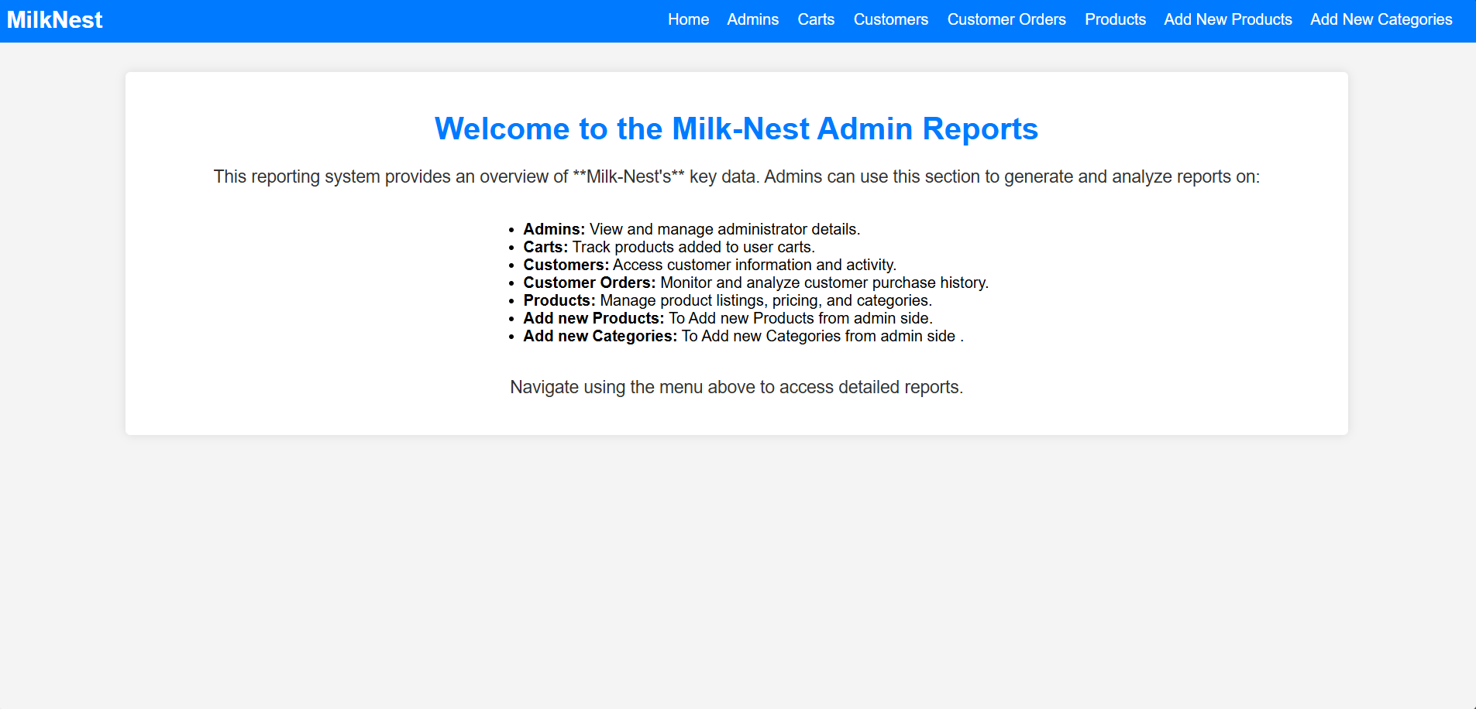

* + 1. Admin Report

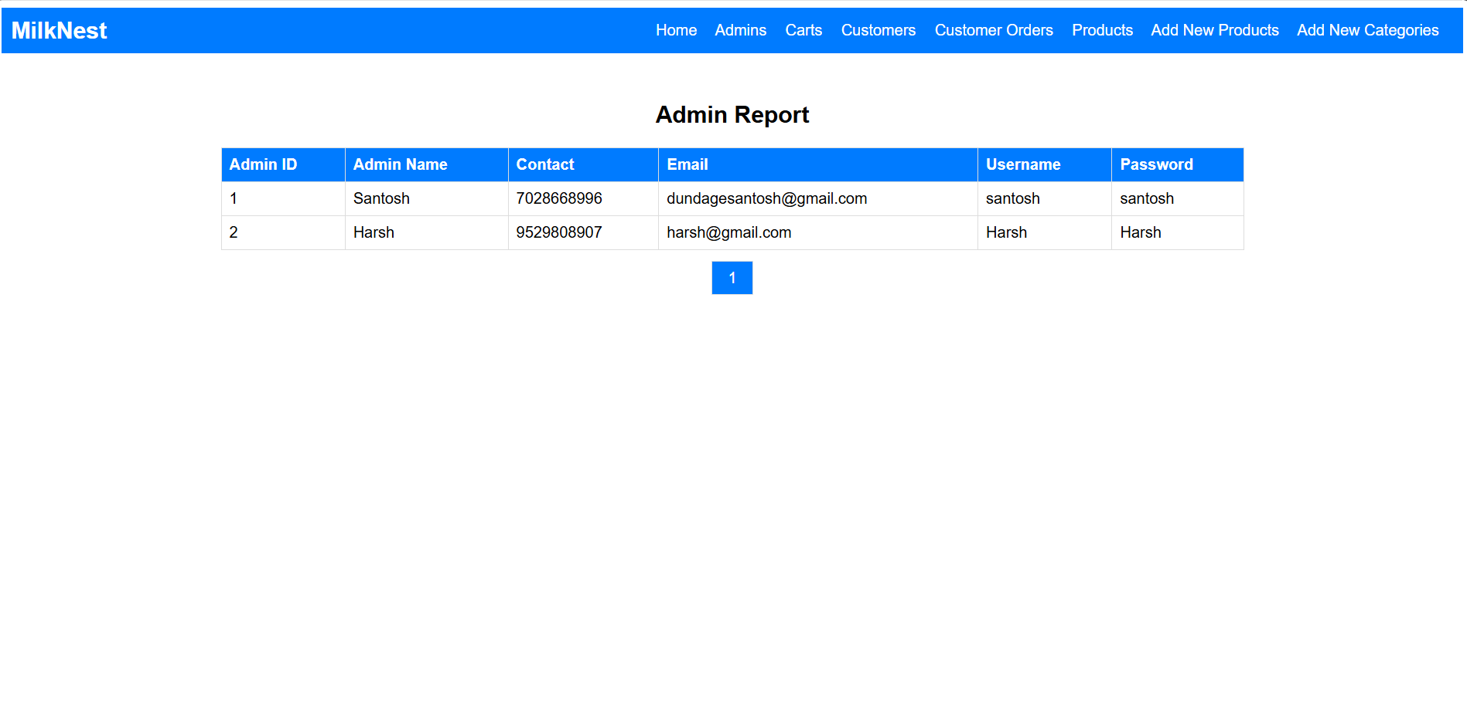

* + 1. Customers Orders Report

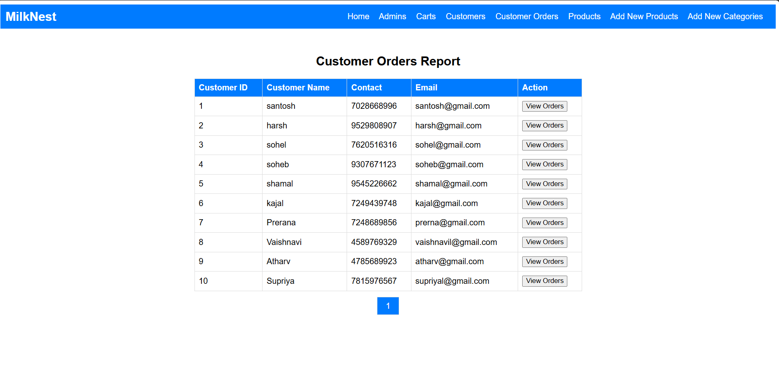

* + 1. Customer Report

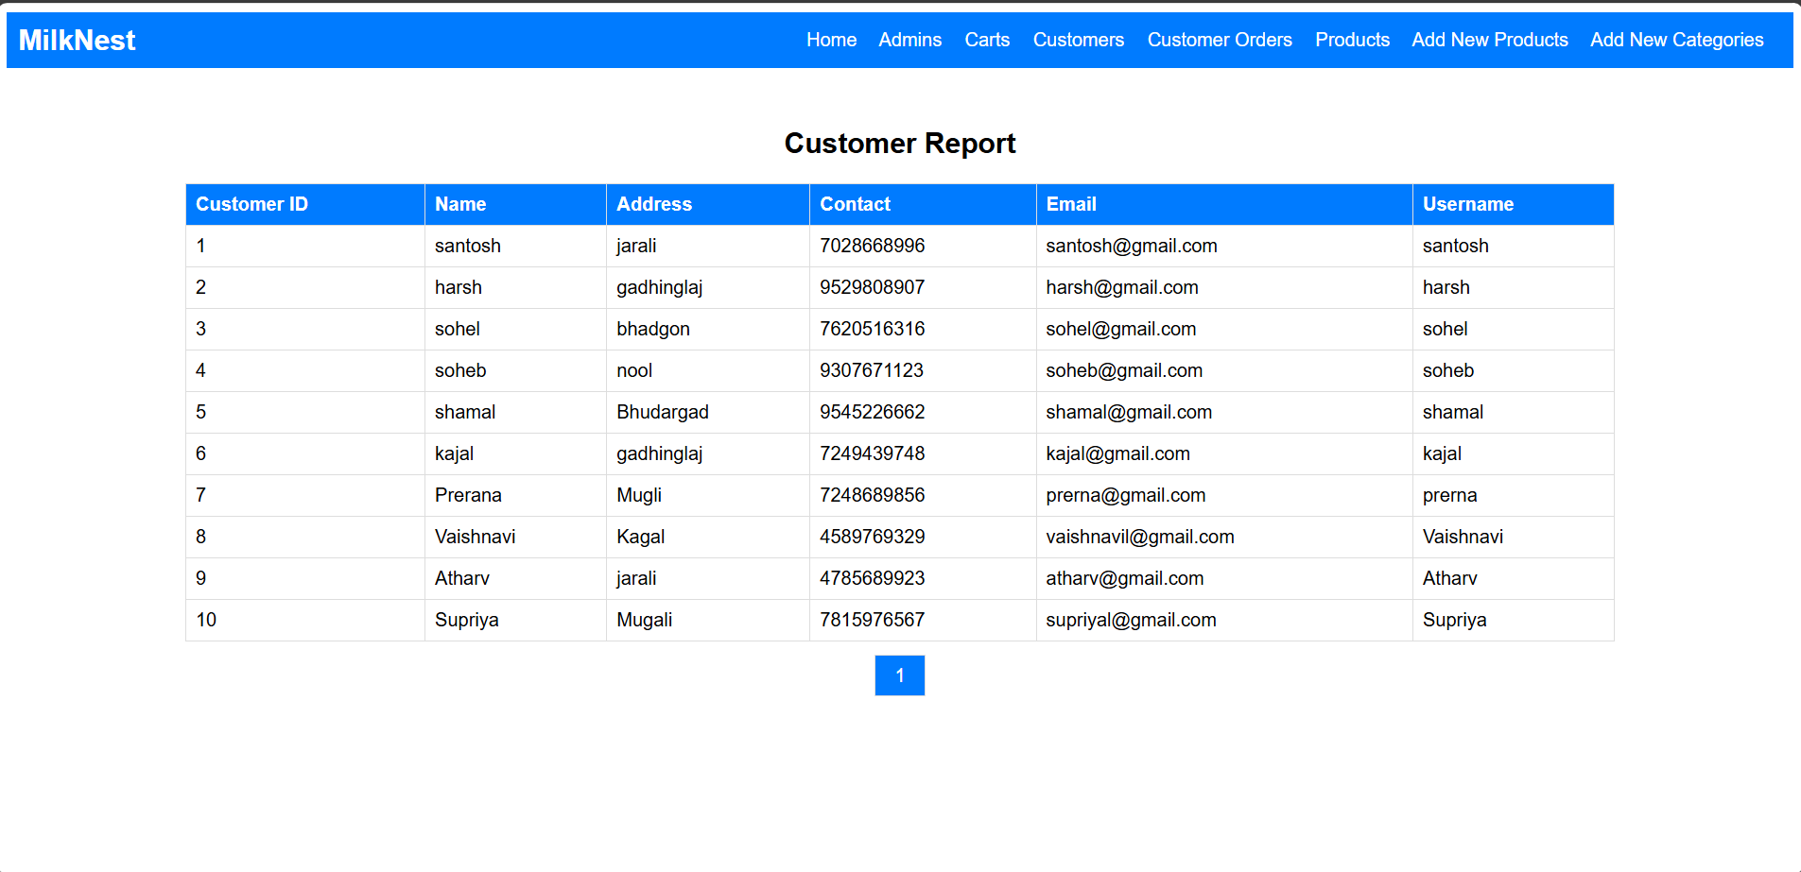

* + 1. Products Report

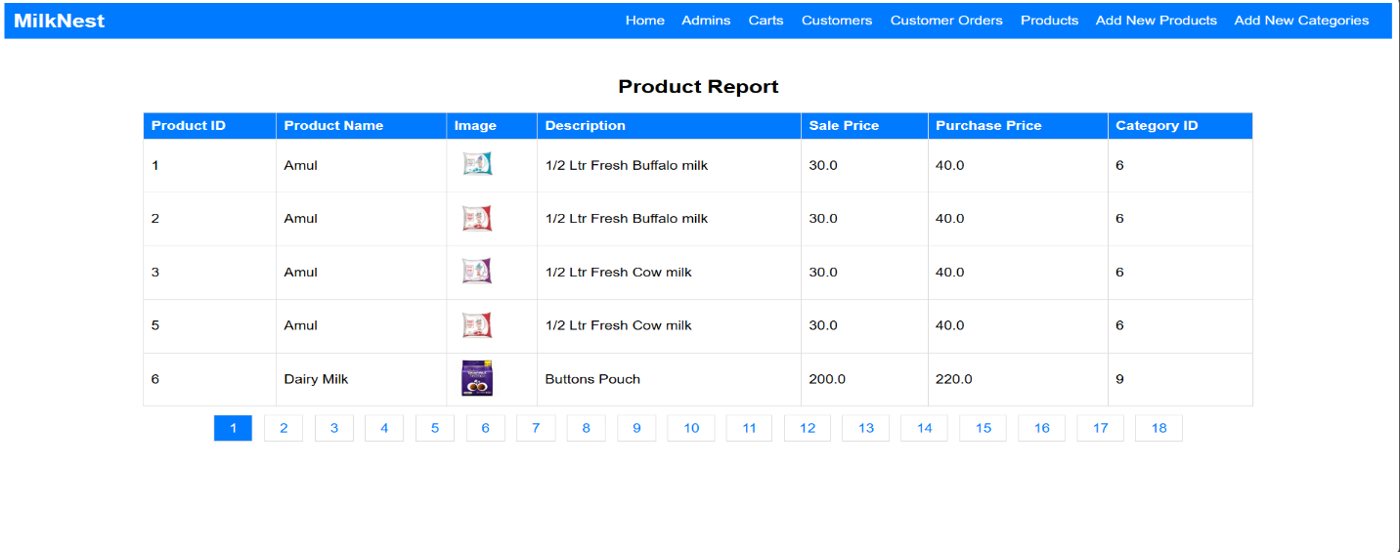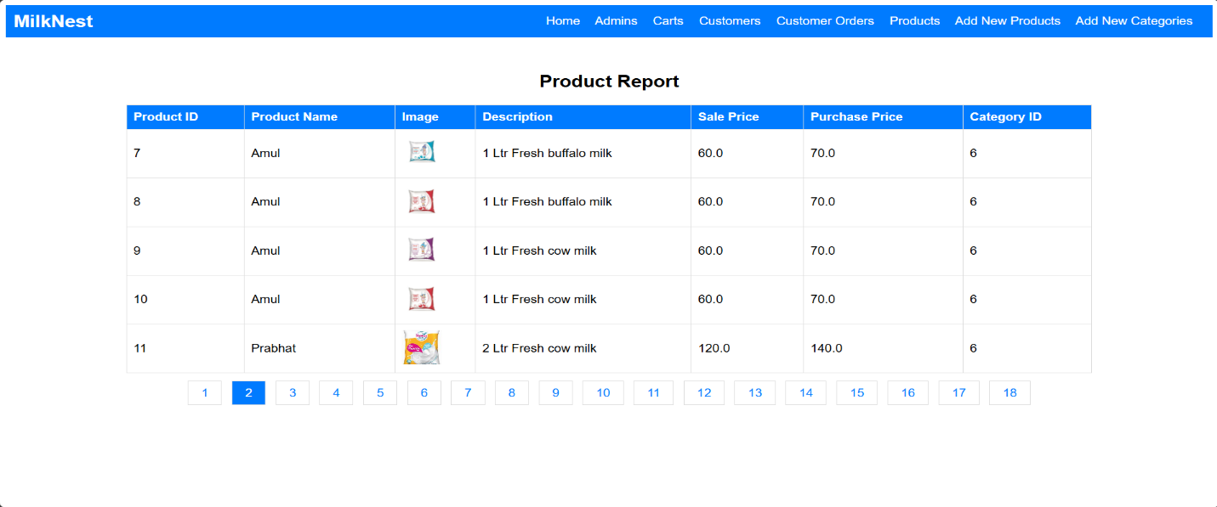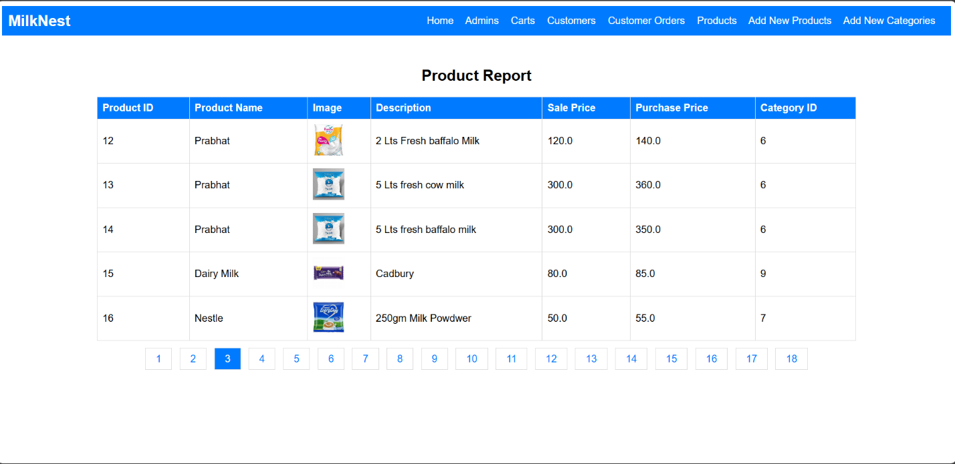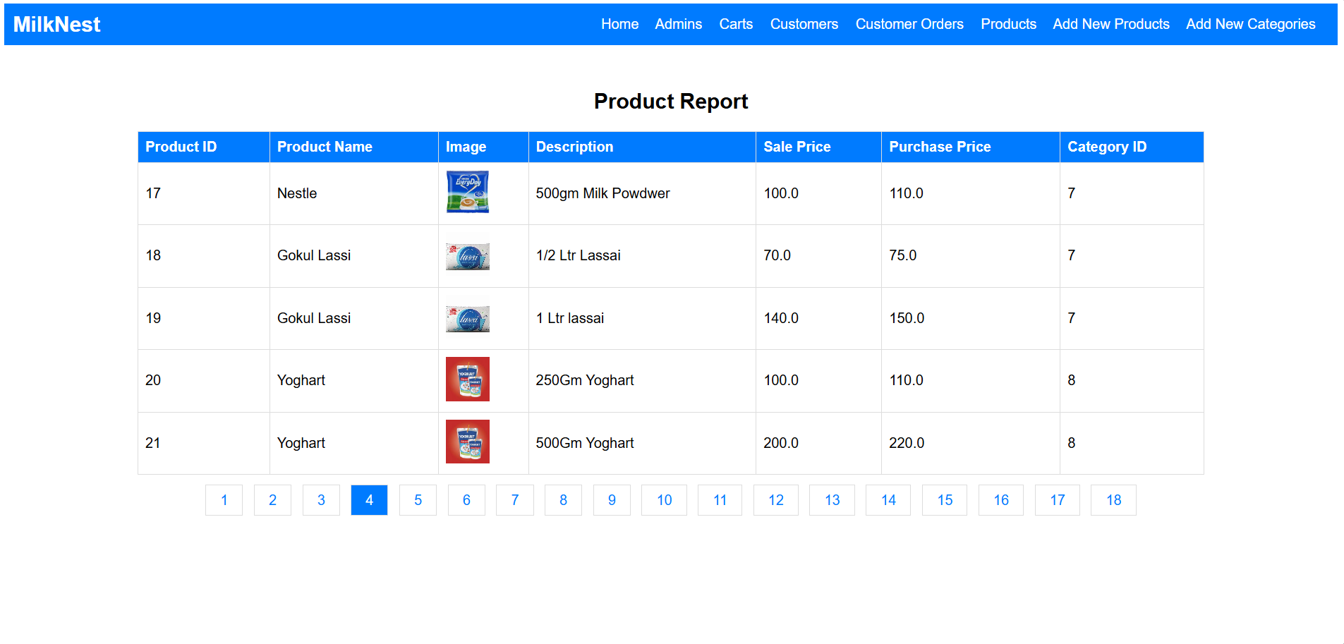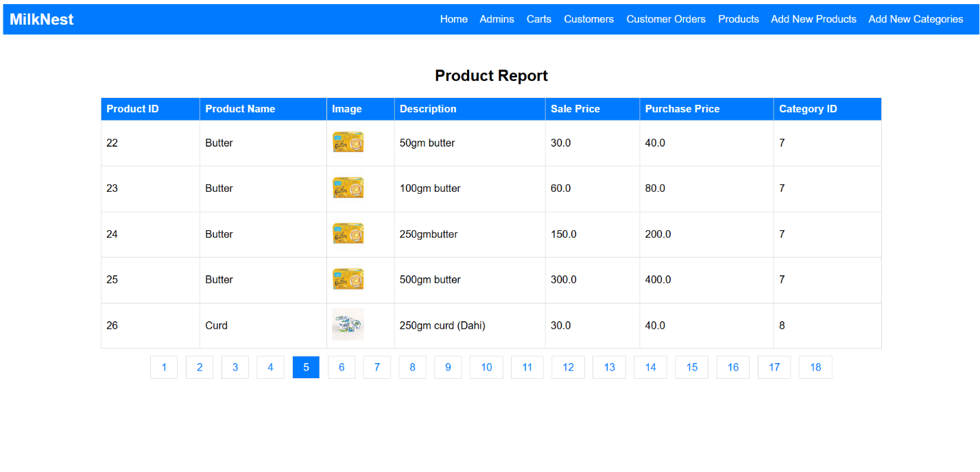

* + 1. Add New Products (Admin Side From)

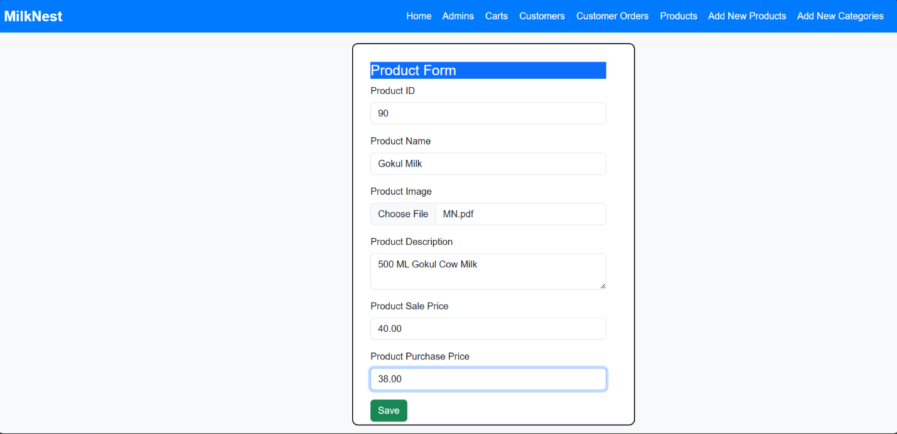

* + 1. Add New Categories (Admin Side From)

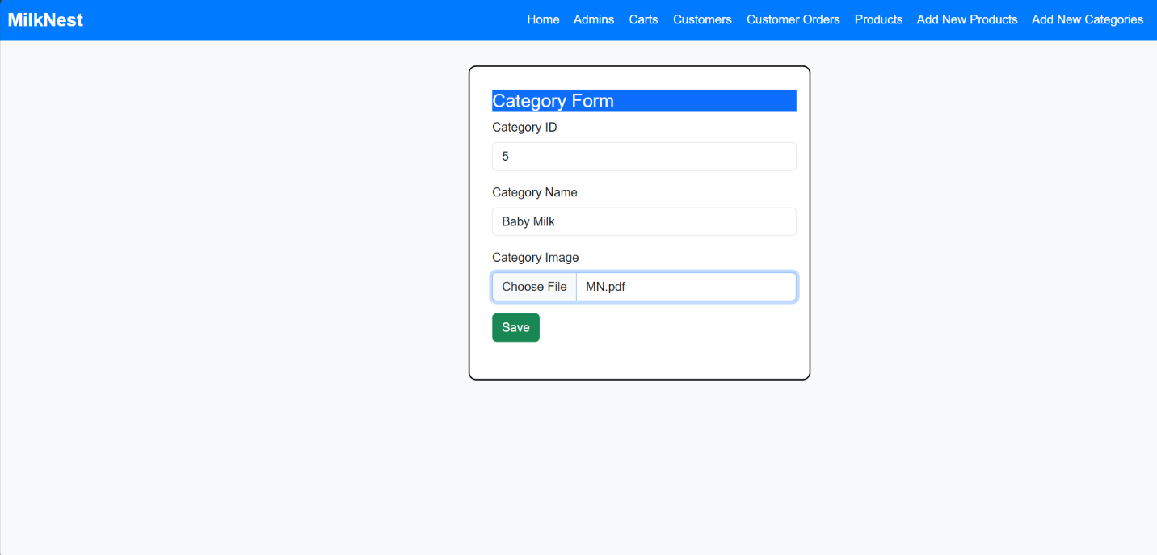

**CHAPTER 7:**

**SUGGESTIONS**

**AND CONCLUSION**

**SUGGESTIONS**

1. User-Friendly Design

Ensure easy navigation, simple UI, and a smooth ordering process.

1. Subscription Model

Offer daily, weekly, or monthly milk delivery plans for convenience.

1. Multiple Payment Options

Integrate UPI, credit/debit cards, cash on delivery, and wallets.

1. Real-Time Tracking

Allow users to track their milk deliveries.

1. Quality Assurance

Highlight purity checks, sourcing details, and certifications.

1. Customer Support

Provide chat support, helpline numbers, and FAQs for assistance.

1. Custom Orders

Enable users to choose different types of milk (cow, buffalo, organic, etc.).

1. Eco-Friendly Packaging

Promote reusable bottles or biodegradable packaging.

1. Local Farmer Partnership

Showcase farm-to-home transparency and support local dairy farmers.

1. Mobile App Integration

Consider launching an app for better user engagement.

**CONCLUSION**

Milk is an essential part of a healthy diet, offering a rich source of nutrients such as calcium, protein, and vitamins. Whether you prefer fresh dairy milk, plant-based alternatives, or fortified options, there’s a choice for everyone. At [Your Website Name], we are committed to providing high-quality, nutritious, and sustainable milk products to support your well-being. Explore our range and experience the goodness of milk in every sip.

**CHAPTER 8**



**BIBLIOGRAPHY**

**BIBLIOGRAPHY**

1. National Dairy Council. *The Nutritional Benefits of Milk*. Retrieved from [www.nationaldairycouncil.org](https://www.nationaldairycouncil.org)
2. World Health Organization. *Milk and Dairy Products in Human Nutrition*. Retrieved from [www.who.int](http://www.who.int)
3. USDA. *Dietary Guidelines for Americans: Dairy Recommendations*. Retrieved from [www.usda.gov](https://www.usda.gov)
4. Harvard T.H. Chan School of Public Health. *Milk and Health: The Pros and Cons*. Retrieved from [www.hsph.harvard.edu](https://www.hsph.harvard.edu)
5. Food and Agriculture Organization (FAO). *Milk and Dairy Products: Production, Consumption, and Health Benefits*. Retrieved from [www.fao.org](https://www.fao.org)
6. Mayo Clinic. *Lactose Intolerance and Dairy Alternatives*. Retrieved from [www.mayoclinic.org](https://www.mayoclinic.org)
7. National Institutes of Health (NIH). *Dairy and Bone Health Research*. Retrieved from [www.nih.gov](https://www.nih.gov)
8. Google Search. Various Articles on Milk and Nutrition. Retrieved from [www.google.com](https://www.google.com)
9. OpenAI's ChatGPT. Information on Milk and Dairy Products. Retrieved from <https://openai.com>
10. Gemini AI by Google. Insights on Milk and Nutrition. Retrieved from <https://deepmind.google>